September 29, 2026

Dr. Jenahvive Morgan
College of Engineering
Michigan State University
219 Wilson Road
East Lansing, MI 48825

Dear Dr. Morgan,
Attached is a copy of Section 2, Team 7’s Project #1 Checkpoint Report for EGR 100.
This report describes the design and prototyping process for a localized mobile application, “Night Owl Dining,” engineered to resolve late-night dining access challenges faced by students at Michigan State University. The multi-screen graphic user interface was optimized for real-time navigation by integrating user-preference selection algorithms. Programmatic constraints and execution environments were systematically evaluated and analyzed through localized participant beta testing.
Utilizing the MIT App Inventor development platform, the final architecture was engineered as a modular three-screen system relying on a unified localized database and an asset registry. Screen 1 establishes a centralized user dashboard featuring dynamic sorting configurations for sit-down and take-out dining, enabling users to execute custom selection queries and launch external merchant web interfaces. Screen 2 integrates a real-time user-directed Web Viewer interface paired with custom logic blocks to initialize routing requests. Screen 3 deploys a dedicated Web Viewer component running a Google Maps API framework, which dynamically reads user and restaurant coordinates to compute real-time driving durations. When evaluated against design criteria, the prototype successfully satisfied all structural economic parameters and technical data-maintenance limitations.
I hope this report meets your requirements, and any questions will gladly be addressed by email.
Sincerely,
Andrew Sreseli, David Parker, Anthony Marchese, Daniel Wang
INTRODUCTION

The purpose of this project is to solve a localized, real-time navigation problem faced by Michigan State University students: locating open food options after major campus dining halls close, and tracking variable late-night restaurant operating hours along Grand River Avenue. Students studying late at the library, working on engineering projects in computer labs, or returning from late-night student activities currently lack a centralized, real-time utility.

Popular commercial platforms frequently fail to capture spatial efficiency and access to essential resources in dense college environments, highlighting the necessity for a specialized, localized mobile application. The Night Owl Dining mobile utility addresses these critical operational inefficiencies by providing an accessible, real-time optimization tool engineered to bridge this disparity.

METHODS

The Night Owl Dining application was developed and prototyped using the MIT App Inventor programming environment. The software architecture was structured as a modular three-screen system utilizing a unified asset registry.
Screen 1 serves as the main user dashboard, featuring categorized restaurant lists for sit-down (Figure 1) and take-out (Figure 2) dining options. Users interact with selection buttons to choose a specific venue, which triggers logic blocks to launch external merchant links.
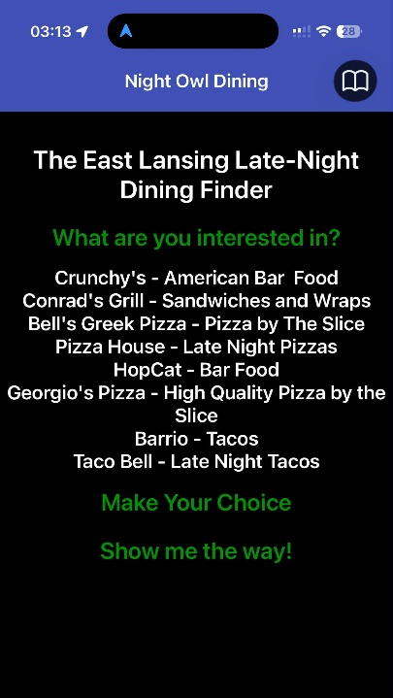
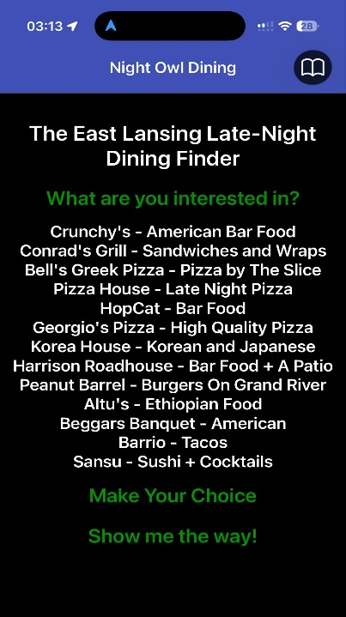

Figure 1: Screen 1 user interface layout showcasing localized sit-down dining options.
Figure 2: Screen 1 user interface layout showcasing localized take-out dining options.

Screen 2 (Figure 3) integrates a real-time Web Viewer component paired with a dedicated button to initialize direction queries. Screen 3 (Figure 4) embeds a secondary Web Viewer interface running a live Google Maps webpage structure. This component reads the user's manual selection inputs to display directions and calculate driving times to the chosen restaurant location along Grand River Avenue. The layout of the graphic user interface and its underlying block logic configuration are shown in designated figures.

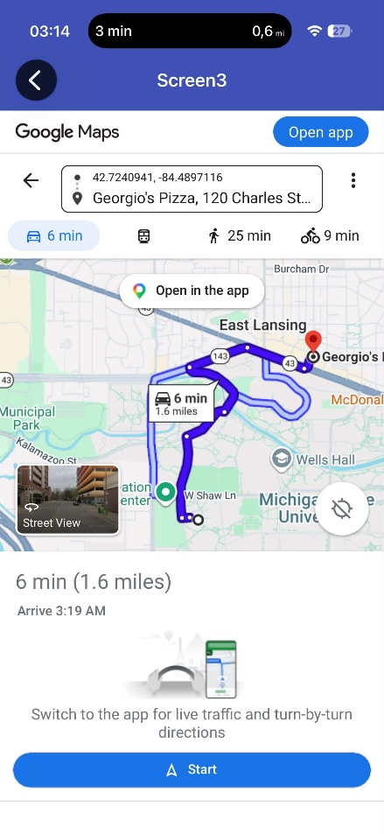
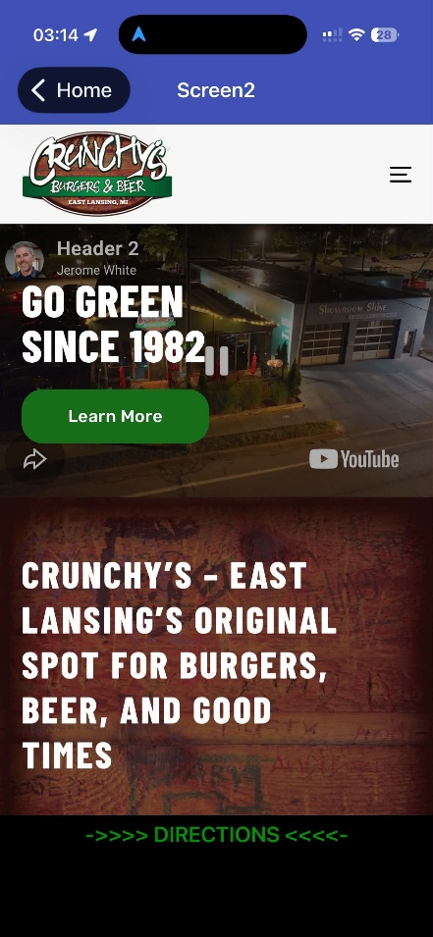

Figure 4: Screen 3 layout displaying routing via the Google Maps component.
Figure 3: Screen 2 layout initializing the dynamic Web Viewer merchant interface.

The code for Screen 1 (Figure 5) read what the user chose from the first ListPicker, then generated a new list that featured the choices available that correlated with the interest the user chose. The second ListPicker then allowed the user to make a choice of which restaurant they wanted to go to, the choice was saved with a tinyDBK. Finally, the button brought the user to Screen 2 when pressed.
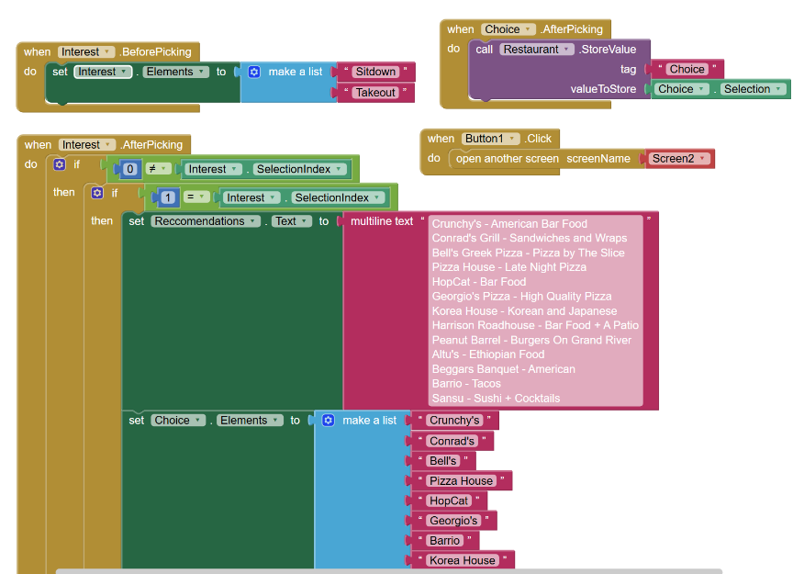

Figure 5: Code operating Screen 1

The code for Screen 2 (Figure 6) read the tinyDBK to get the choice of the user, then directed the WebViewer to the associated website of the restaurant chosen by the user. The button functioned to take the user to Screen 3 when they were ready.
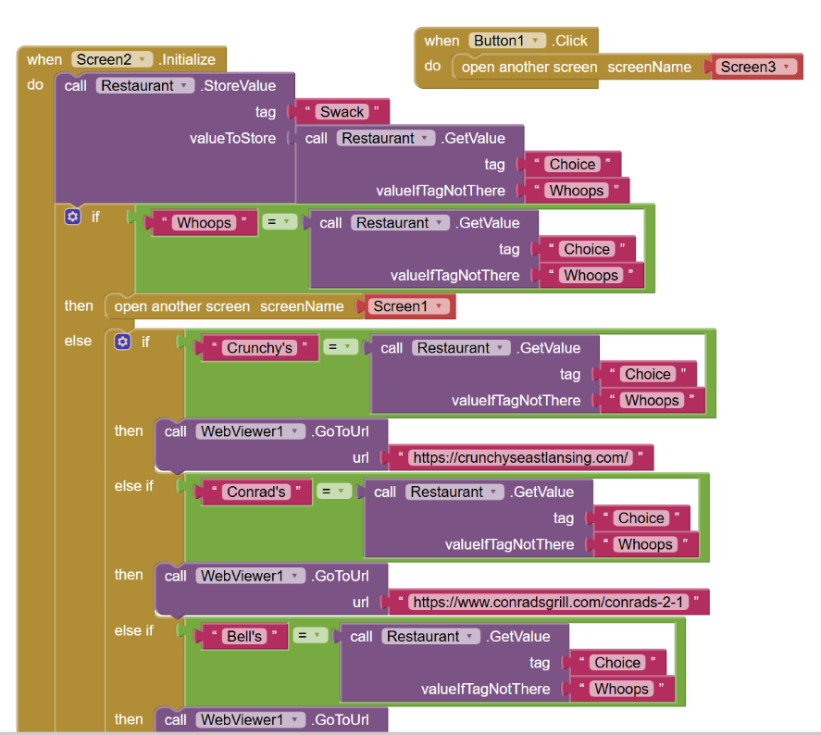

Figure 6: Code operating Screen 2
The code for Screen 3 (Figure 7) read the choice of the user through the tinyDBK again before it directed the WebViewer to Google Maps with the directions to the restaurant.
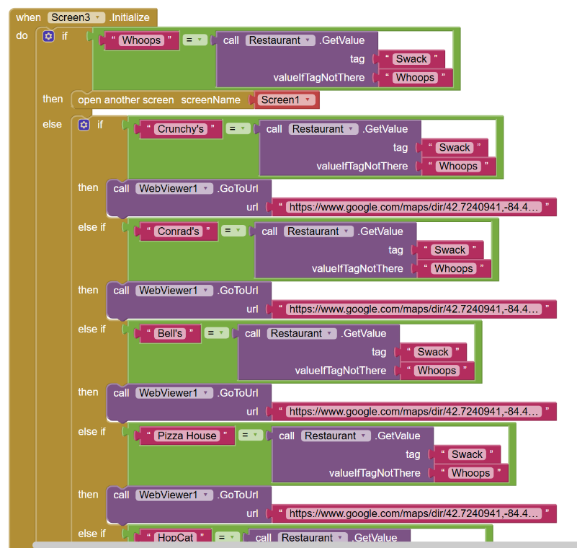

Figure 7: Code operating Screen 3

RESULTS

To evaluate user requirements and validate application performance, a targeted beta testing pool consisting of 16 Michigan State University students was systematically surveyed. Quantitative user feedback metrics were compiled into a centralized asset database to analyze baseline late-night demand along Grand River Avenue alongside user satisfaction trends. A summary of the compiled statistical parameters is detailed below in Table 2.

Table 1: Statistical Survey Parameters for Target Student Focus Group

Survey Parameter | Sample Size (N) | Parameter mean (μ) | Standard Deviation (σ)
Late-night Dining Frequency (1-5) | 16 | 3.94 | 1.03
App Helpfulness Rating (1-5) | 16 | 3.56 | 0.79
App Satisfaction Rating (1-5) | 16 | 4.31 | 0.58

As detailed in Table 1, the targeted user population reported a high frequency of late-night dining demand (μ = 3.94) with a standard deviation of 1.03, confirming a widespread and frequent need for a centralized campus information utility. Following interaction trials with the software prototype, the application achieved an engineering validation metric characterized by an App Helpfulness Rating mean of 3.56 out of 5.00 (σ = 0.79).
Furthermore, the overall user software interface and multi-screen system workflow yielded a very high App Satisfaction Rating (μ = 4.31). The low standard deviation recorded within this parameter (σ = 0.58) demonstrates consistency in user utility, confirming that the modular asset architecture successfully satisfied data accessibility requirements under standard campus operational constraints.

To visually evaluate the correlation between baseline student demands and prototype performance metrics, individual respondent data entries were mapped onto a coordinate matrix, as illustrated below in Figure 8. Because multiple survey responses shared identical integer values, a minor visual offset was mathematically applied to overlapping coordinates to ensure all 16 individual respondent data points remain distinct and legible.

Figure 8: Student App Satisfaction Rating as a Function of Late-Night Dining Problem Frequency

The resulting spatial distribution in Figure 5 demonstrates a strong, positive qualitative clustering between high problem frequency metrics and elevated software interface satisfaction scores. Notably, respondents registering a maximum late-night operational demand factor of 5.00 consistently recorded application satisfaction scores at or above 4.00. This correlation validates the prototype's algorithmic positioning, indicating that the multi-screen architecture scales effectively to meet the criteria of heavy-user student demographics along Grand River Avenue.

CONCLUSION

The objective of this project was to engineer a localized software utility, Night Owl Dining, to resolve the real-time spatial navigation and informational disparities experienced by students seeking operational food resources after standard campus dining hall closures at Michigan State University. By utilizing the MIT App Inventor programming platform, a modular three-screen user interface was successfully prototyped and validated against technical and student demographic constraints.
Evaluation of the final system design using survey testing metrics from a target student focus group demonstrated high operational success. The software achieved a mean App Helpfulness Rating of 3.56 out of 5.00 and an App Satisfaction Rating of 4.31 out of 5.00, proving that the localized menu filtering systems and embedded Web Viewer map routing mechanics functioned with high consistency across the testing pool. While the evaluation was structurally limited by an academic project sample constraint of 16 participants, the strong positive correlation between high user problem frequencies and elevated satisfaction metrics confirms that the application architecture successfully resolved information gaps along Grand River Avenue. Future iterations will expand backend database structures to integrate automated, real-time operating hour update blocks.

REFERENCES

References are placed in a separate section at the end of the document. They should be listed in the order they appeared in the text. Use the IEEE reference style. Refer to the reference in the text by simply placing the reference number in square brackets, for example [1], in the text where the reference is made. For websites use the first example below, and for an article from Google Scholar use the second example below. Also, for online sources, if no date can be found, use the date that the website was accessed.

Follow the sample references below or use the website:
https://ieeeauthorcenter.ieee.org/wp-content/uploads/IEEE-Reference-Guide.pdf

[1] J. K. Author and T. Writer, “Title.” Website Title. Date Accessed. [Online]. Available: http://www.(URL)
[2] J. K. Author, “Name of paper,” Title of Periodical, vol. x, no. x, pp. xxx-xxx, Abbrev. Month, year
[3] J. K. Author, “Title of chapter in the book,” in Title of Published Book, xth ed. City of Publisher, Country: Abbrev. of Publisher, year, ch. x, sect. x, pp. xxx–xxx

